John Cihocki
RPS Web Access 399
Advisor: Peter A. Dinda
3/20/03

Abstract
RPS – the Resource Prediction System – is a set of tools and libraries for the distributed sensing, computing, and prediction of system and network resources (1). Currently, the tools are implemented in C++ and are run from a command line. To use the toolkit, then, requires access to a terminal on a machine with an RPS install, and therefore an account on that machine. This is logical, as it would be a security compromise to allow public traffic to create sensors and monitor the resources of a sensitive system, and it would be clumsy or even undesirable to have to secure an entire network from that traffic just to use RPS. However, one can imagine a situation where it would be useful to be able to listen to sensors on some system or systems without the ability to set them up or administrate them. It then follows that access to the listener command line tools through an http interface would be a convenient way to control to which tools an unauthorized user – perhaps even authorized users as well using http security or https – would have access. This would also create a more intuitive interface to the RPS system, as not everyone is familiar with CLUIs (though one could imagine anyone interested in RPS was), and there is some syntax that is required that can cause segmentation faults in the tools if incorrect. The Common Gateway Interface for http could then generate the syntax from a graphical interface oriented html page. This paper, and the work it describes, focuses on the creation of such a hypertext interface to the RPS sensor clients using the Hypertext Markup Language, The Common Gateway Interface using Perl, and an extremely lightweight Perl http daemon that could be installed on any machine along with RPS to serve the web system.

The http daemon
The chosen httpd for this project was perlwebserver(2). It was chosen for its combination of miniscule footprint (well under 1MB on disk), multiple connection capability, and native support for Perl CGIs. The main drawback is that it is development code, and therefore unstable, mildly unpredictable, and more or less unsupported. However, since the CGI scripts use the same Perl module “CGI” as more common, fully supported web servers such as apache with modperl, the system is fully portable to a more dedicated server. Another weakness of perlwebserver is that it has to work much harder than a more robust web server to serve documents. Each request made results in a new process being created and destroyed. Also, the Perl interpreter itself, lamentably, is painfully slower than machine code generated by a C compiler. It is possible that requests, if frequent enough to perlwebserver, could have an effect on the very resources RPS is sensing on that system, if any. For this reason, it is recommended that perlwebserver be run on a machine where sensors are not running, and if that is possible, a more powerful machine, or one with a low sensor frequency or lower importance.

The Query Interface – The “Front End”

The interface for querying RPS through http is built hierarchically. For more advanced usage, at the top level there is a generic query form which allows the user to simply specify a client from a dropdown list, and type in the command line arguments as they would if running from a terminal. A dropdown list is universally the method to select the client you want to use in a query, however, more specific query forms may have a limited set of tools available or may have a pre-selected client to run. At the next level of detail there are forms for queries of buffered measurements and non-buffered measurements. These forms allow users to use SourceBuilder, which is a set of GUI objects that they can manipulate to build the communication string passed to the client as the source of data. The third level of detail includes individual query forms for each client tool in RPS. These forms, which we will call QueryBuilders, expose all the functionality for each tool for expert use, and also provide the SourceBuilder. The three generic forms provide one click access down to the QueryBuilder of whichever client is currently selected.

The Query Handler – The “Back End”

It is the responsibility of the Query Handler to build the proper command line for a certain tool and execute the program, thus generating the output desired by the user. This is not as simple as it sounds, as the handler would rather not allow invalid input to a program, causing a crash, or input which inadvertently or intentionally attempts to open security holes in the RPS system. With the exception of pred_reqresp_client and predlatclient, each buffered or non-buffered client accepts the same command line arguments. For a stream client, the argument is simply the source of the data stream. For a buffered client, the arguments are the number of values we are seeking and the source of the data stream.

The Query Handler was implemented in Perl, using CGI.pm. It should be pluggable to any unix web system with perl CGI capability and RPS. The version it was tested with is 5.6.0 on linux kernel version 2.4.18.

Displaying Output

Displaying the output generated by RPS clients is not straightforward. Firstly, visual elements apart from the actual output are necessary for convenience to the user, and for proper functionality. Next, output is generated differently for buffer clients and for non-buffer clients. For buffer clients, the tool simply returns a certain number of cached measurements. However, streaming clients continuously output data at some frequency. This brings up the issue of what to display for stream clients. It could confuse browsers if the Query Handler just continues to send new data on the http connection as it comes through the standard output. This could cause the page to not be displayed at all, as a browser could wait for connection close. Also, however, if the stream client runs for a specified short period of time and quits, if the frequency of the sensor is too low, there is a good possibility you will not receive any output from the tool. The solution the interface implements is to run until one line of output is generated. Then, for stream clients, the results page will refresh at some frequency, returning one new measure each refresh. For cohesiveness previous output will persist, so that the output from the web interface may approach what one would expect to see from a terminal. The refresh will of course be killable with one click, so there is a means to squelch the visual annoyance. For ease of use, the QueryBuilder corresponding to the tool that has been run will always be present on the output page for quick resubmission, and the default values for it will be the ones used to create the currect query.

HTTP Interface Extensibility

RPS is currently evolving as a research tool. It therefore makes sense that an HTTP interface to it should also have the ability to adapt to new tools, CLUI interface changes, etc. An attempt at this was made using the Macromedia Dreamweaver tool set. Dreamweaver allows you to house common code in libraries in a very similar way to C++. By making a code portion a library, and inserting that library object into a page, that portion of the page becomes a slave to that library object. If the code in the library object changes, that change propagates down to its slaves. This is accomplished using the Dreamweaver software, and still results in purely static HTML pages. HTML Templates are a similar tool which the interface has utilized to ease creation of new query forms. Pages which use a template are slaves to the entire template, and will respond to changes within it, but with editable regions which template updates ignore. For instance, there is a BufferedQueryBuilder.dwt template which is used to create each individual QueryBuilder page for clients which access buffered streams. On the backend, the Perl code is very abstracted to allow similar “one change” behavior modification. All of these features endeavour to make the HTTP interface to RPS as extensible and flexible as possible.

Results

There is still some difficulty with running perlwebserver on the cluster machines. So testing at this point should be done using apache or some supported web server. The static pages seen here are being served off of perlwebserver on tlab-13.cs.northwestern.edu. The dynamic shots shown here were generated by using IE to generate the proper query string for rpsquery.pl, and then running it with the query string
interactively. The html was then be saved and viewed statically.

Universal Client Interface – Lowest level of detail
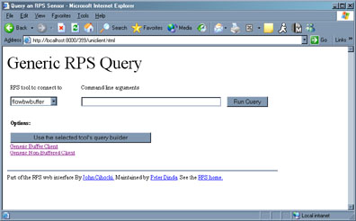

Generic Buffer Client
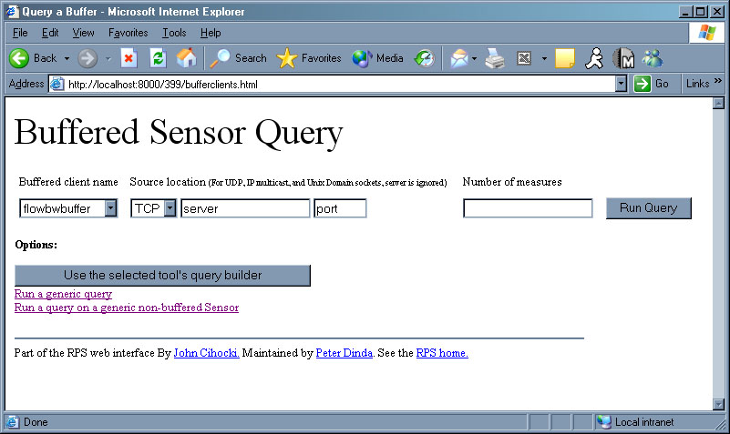

QueryBuilder for blowbwbufferclient
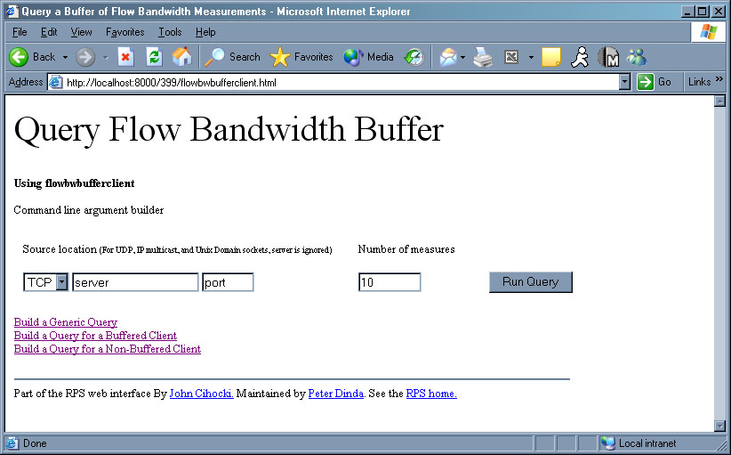

Future Extensions

The web interface described herein still requires a fair amount of knowledge about the current state of RPS. Mainly, which sensors are running on which machines, and which machine was doing prediction. If there were some sort of database of currently open sensors and predictors, there could be a web front end that dynamically generates the proper queries using the proper tools to access them. Another useful tool would be front-ends for all of the RPS toolkit, and http or https authentication to authorize users so that remote administration of RPS could be handled by the web. Such a system would eliminate the need for terminals to use RPS altogether. Embedded graphing utilities using java applets or dynamic image generation could help with prediction visualization in some version of the RPS http interface as well.

References

- Peter A. Dinda, David R. O’Hallaron. “An Extensible Toolkit for Resource Prediction In Distributed Systems” July 1999, Carnegie Mellon University
- Spencer Christenson “perlwebserver” http://perlwebserver.sourceforge.net/

